Landen Barber
Final Evaluation Preparation

Requirements

Updated plan post meeting
After the meeting I understood better that these last features were more focused on customization rather than accessibility, though they may be able to supply a little more support for people with disabilities, they are closer to busy work than being a proper design choice that forwards accessibility.
I have decided to scale back on these little features, keeping the more important ones, and am considering how I can make the gyroscope a more integral part of the design rather than a feature. I think it would be useful to mix these planned features and further intertwine them with the one-handed form factor to make something more mobile and simpler to use. Though I am not confident this is enough of a change in design to make it accessible by design.
Therefore, my biggest goal over winter break is to think of a better project design. I need to plan better balance between hardware, software, and customizability. To start I will define what kind of disabilities I want to support more specifically so that I have clear boundaries to work off of. Knowing if I want to include other disabilities will also help with the design. Some ideas/parts to consider are eye tracking, face/head tracking, pressure sensitivity, voice commands, proximity sensors, magnetic switches, and auto assisted inputs.
I still also plan to spend some time learning to 3d model properly while I have the free time because the 3d model will be a necessary component for any one-handed device I plan to make.

What I’ve Changed
To start with I will talk about the changes I have made since last meeting to hopefully better fulfill the software requirements. I have decided to scrap the idea of using an app to change settings and key binds. Instead, I will program an overlay that will be on the controller that will have the same functionality. Along with this I will program an overlay keyboard to be able to type using the controller. Another small addition that I will mention is the inclusion of a speaker to allow a degree of narration and feedback.
By switching to an overlay and storing the software on the controller, I can also easily track the inputs of the user and use that history to calibrate and adjust settings in the background to better suit the user, whether its to change button press down timings, or recommending the user change highly used key binds to a more usable button or macro.
To show how these features could be used to enhance the customizability and accessibility of the controller, At the bottom of the page is a short list of the settings that this overlay will be able to configure. Some settings of note are the extensive joystick customization for dead zones, and which directions could be enabled or disabled per stick, and gyro settings to enable and disable specific gestures and change what those gestures could activate.

Thoughts and Plan
I think with these changes, the controller is a better example of a self-constrained system and device that better utilizes the software side of the project to amplify the customizability and accessibility of the controller alongside the mechanical side. Though I want to see what you think about it first, there are some things that I want to update a little more. One of those being the profile and context system because I feel like I haven’t thought about how they would work too well yet.
To start with the plan on how I will move forward, Thursday will be spent updating all these new requirements and documentation for the final report turn in, I will start by rewriting the requirements and moving onto the design diagrams to help me think of what I may have missed to make these changes.
Afterword I will start by thinking and researching more about how the context and profile system should work and figure out if a database is really the best way to do that.
As for winter break, I plan to spend a significant amount of time learning to 3d model and design an initial design of the controller. Doing so may help me learn more about what I should change in order to make the modelling job easier without getting too far into the project.

CAD design
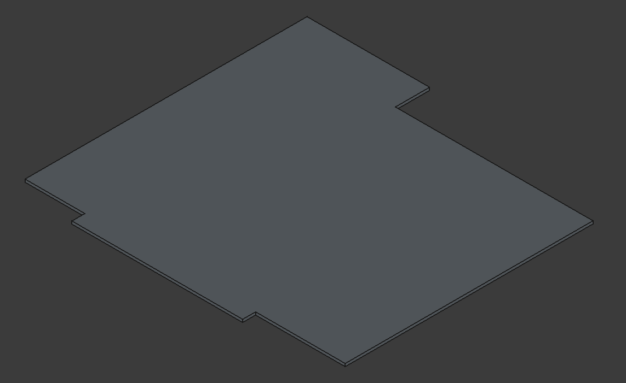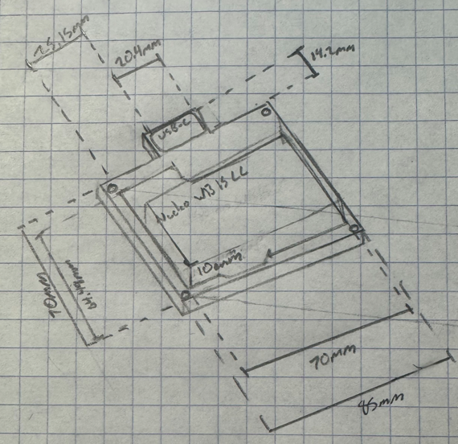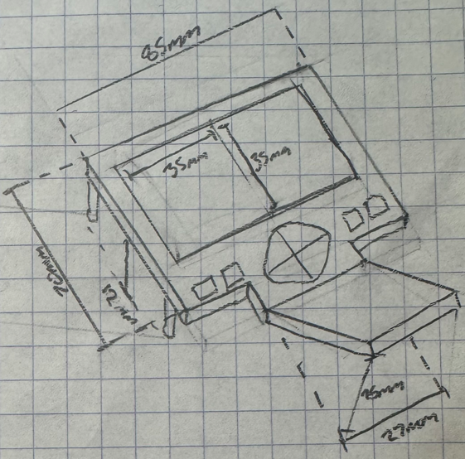
Regrettably, I only just started to learn how to 3d model, I spent a few hours trying to learn recently but did not get very far in parametric 3d modelling. Once I start working on the CAD designs more prominently during winter break, I will start with the internal components and assembly (drawn pictures) and work my way out to the complete assembly. After I am satisfied with that design, I will print it as the first prototype near the start of winter term and see how its physical size needs to be adjusted once seen and felt. The design will feature a few parts that will be printed individually, one being the main piece that will hold the board and some other components on either side, another will be a daughter piece that will attach to the first and hold the buttons and joysticks, and gyro. There will also be 2 pieces that will combine and house these internal components, and another 2 for the handle. Lastly, there will be 1 more that will be the backplate that attaches to the handle, which includes space for buttons, and could be mirrored for more prints for the other hand.

Part list
Part | Amount | Arrival Date
Nucleo WB15CC | 1 | 11/16/25
USB-C Breakout Board | 1 | 11/20/25
PowerBoost 1000C | 1 | 11/20/25
LiOn Battery | 1 | 11/20/25
Analog 2 axis Joystick | 2 | 11/20/25
InvenSense ICM-20948 | 1 | 11/20/25
Coreless Motor | 1 | 11/16/25
Elastic Strap | 1 | 11/19/25
Button, LED, Breadboard Kit | 1 | 12/9/25
Speaker | 1 | ~12/30

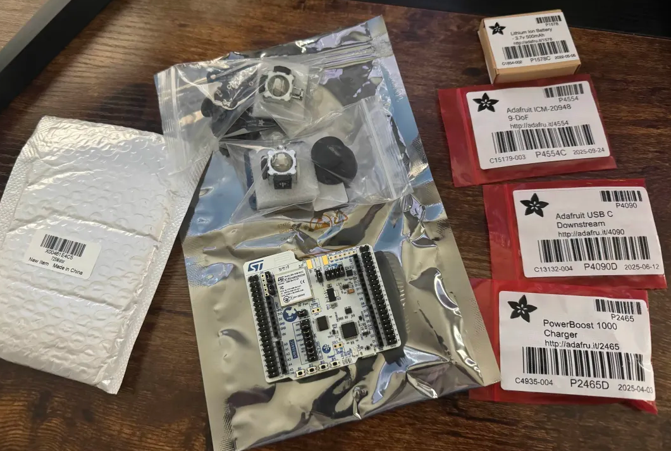
At the moment I have all the critical components, though with the most recent updates to the project, I will probably need to find and order a speaker. I will do more research on this and order around 12/27 so that I can be sure I’m in town when it arrives.

Schedule
Final requirements will be completed by week 1 of winter term.
As mentioned earlier, most of the critical components have already been acquired but the speaker and anything else that I think of will be ordered and delivered by at most January 1st.

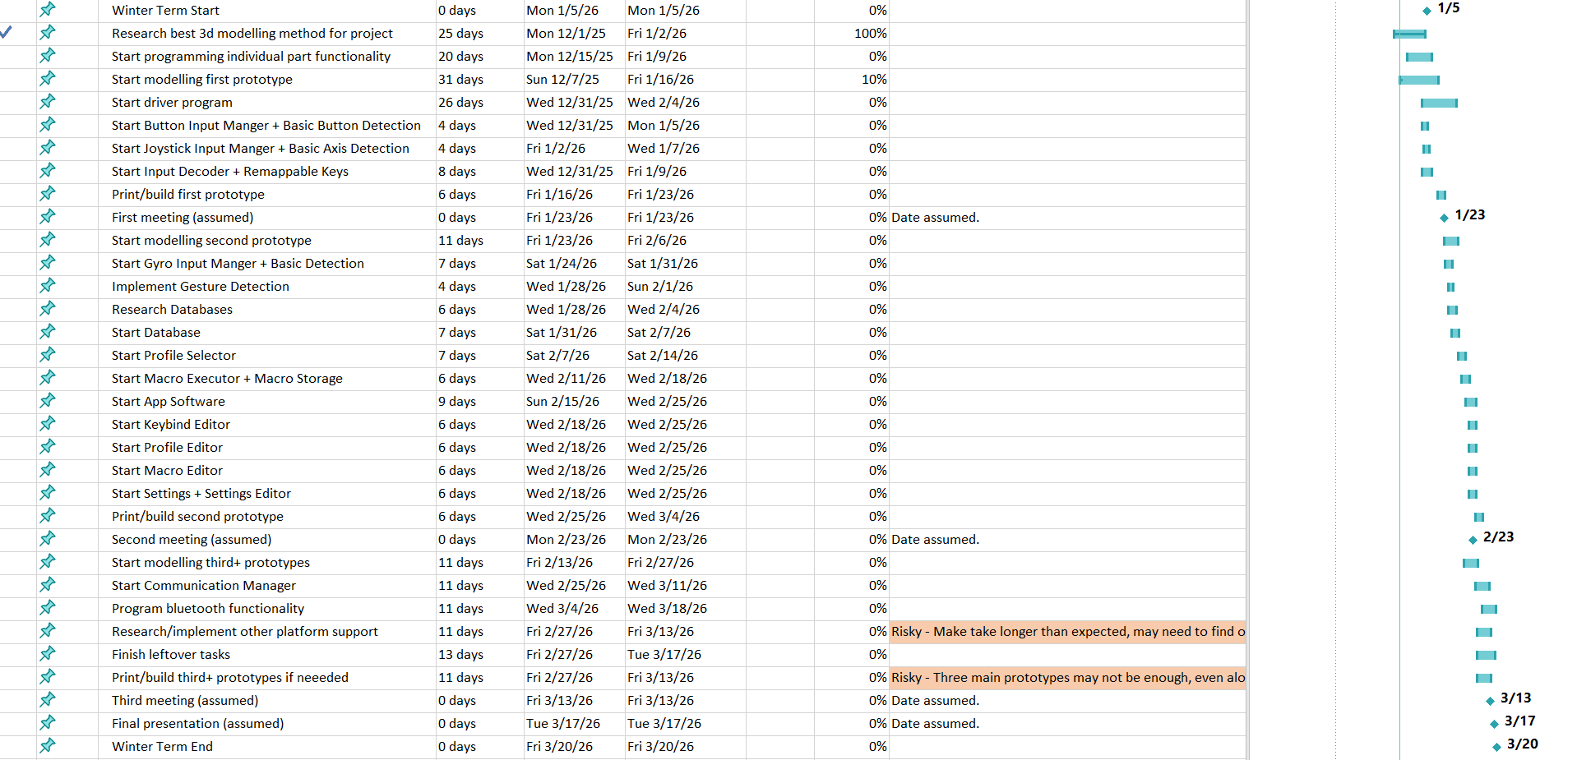
Here Is a screenshot of the plan for winter term which includes dates for both software elements and CAD due dates. I have included dates for each component detailed in the software diagram, starting with input managers to handle buttons, joysticks, and moving to the input decoder and first 3d modelling prototype. Once I have everything put together, I will start working more on other inputs and outputs like gyro, LEDs, and haptic feedback, as well as implementing initial settings within the main driver program. All the while working on a second prototype to fix whatever is wrong with the first and printing and putting together by mid-February. The second half of the term will be focused more on the overall software like the overlay and communication details to be used with other devices. The last week or so of the term will be focused on finishing whatever is left over at the time as well as debugging and testing to better understand the current state of the project.
